GCP:

We can choose 2 versions in 0HANA Express edition

1. HANA server version

2. Server + Application version

We can able to access the XS Features if we are going for the HANA Server version. But still we can able to perform all the administration tasks and native hana application development.

First Create an account in Google Cloud Platform and choose the HANA Express Edition. Fill the below details and click the Deploy button to create the VM.

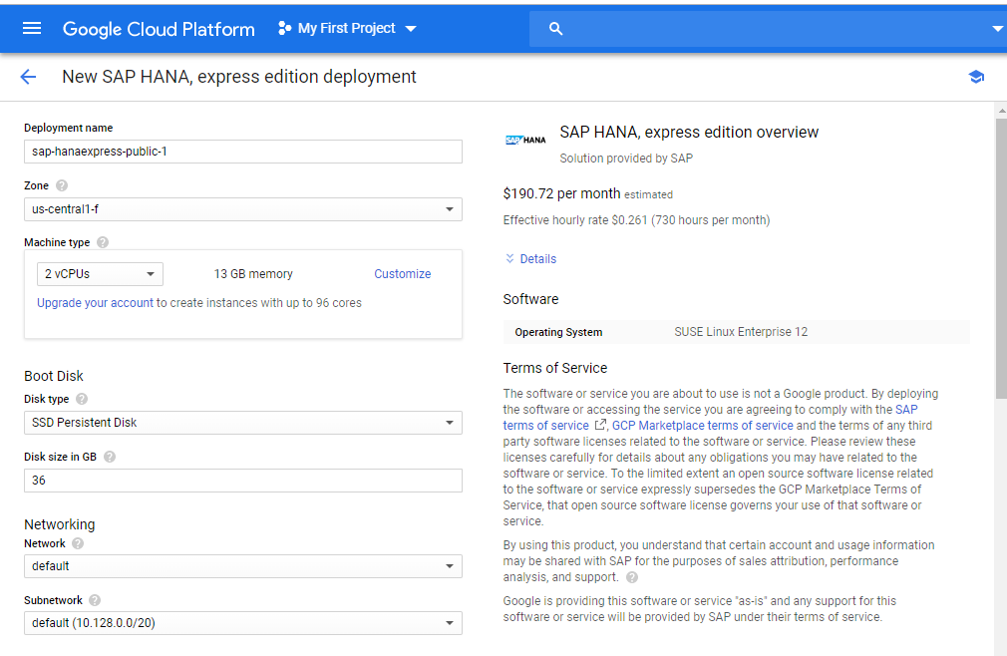

We have mentioned the VM Name as mysap-cloud.

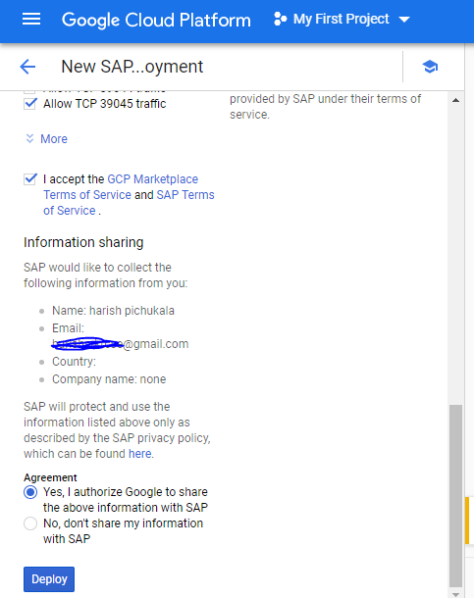

After clicking on the Deploy Button. VM will be ready in 5 mins. We can access the ssh session for OS level access.

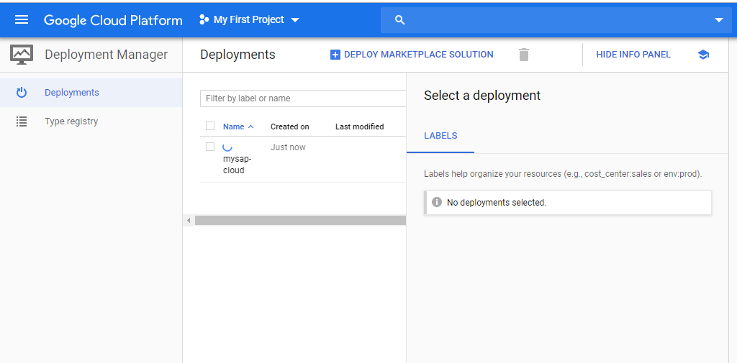

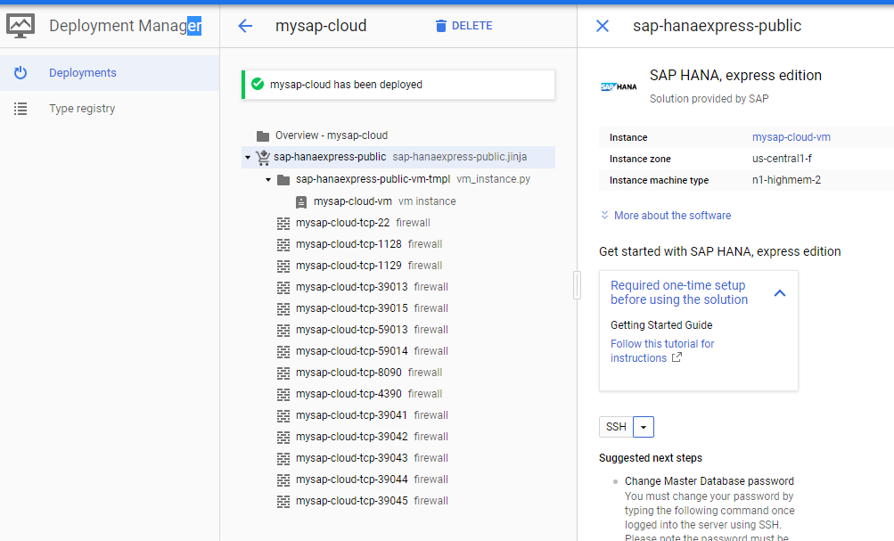

Check the Infrastructure versions and details by executing the below commands

uname -a

cat /etc/SuSE-release

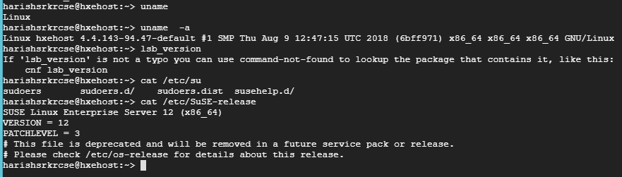

Switch to the hxeadm which is the default hana administration user.

Provide Master Password to access the database.

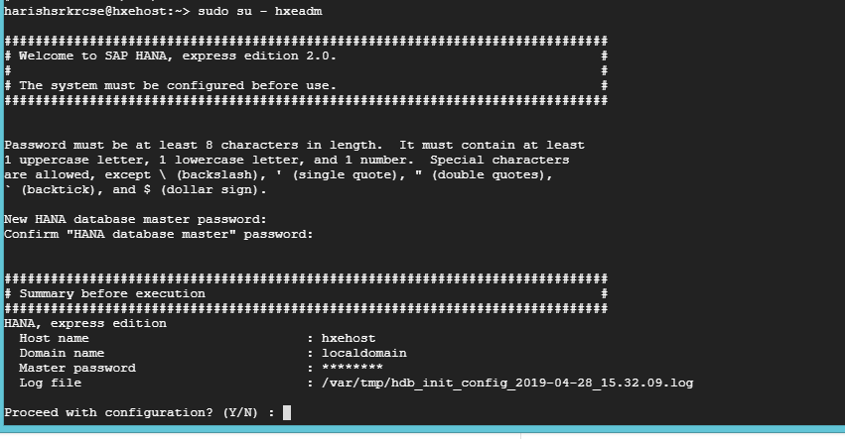

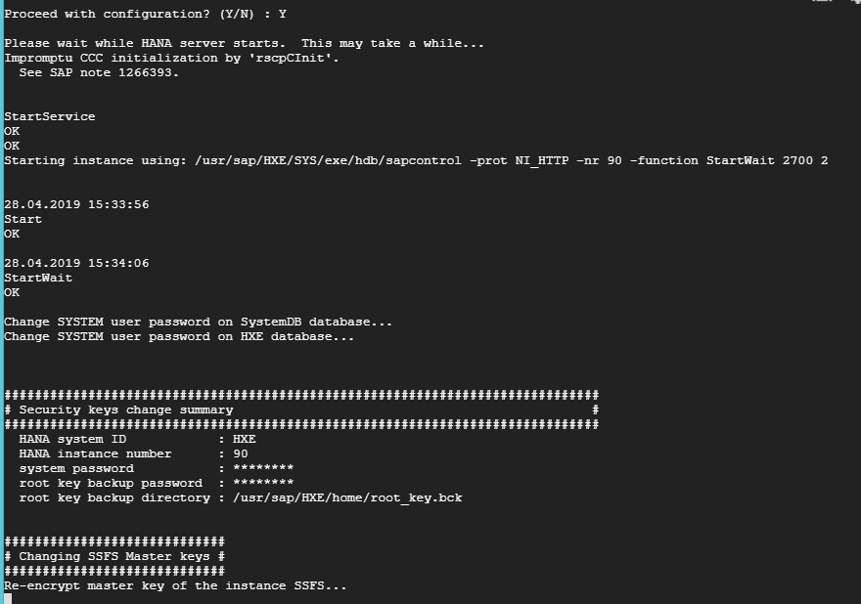

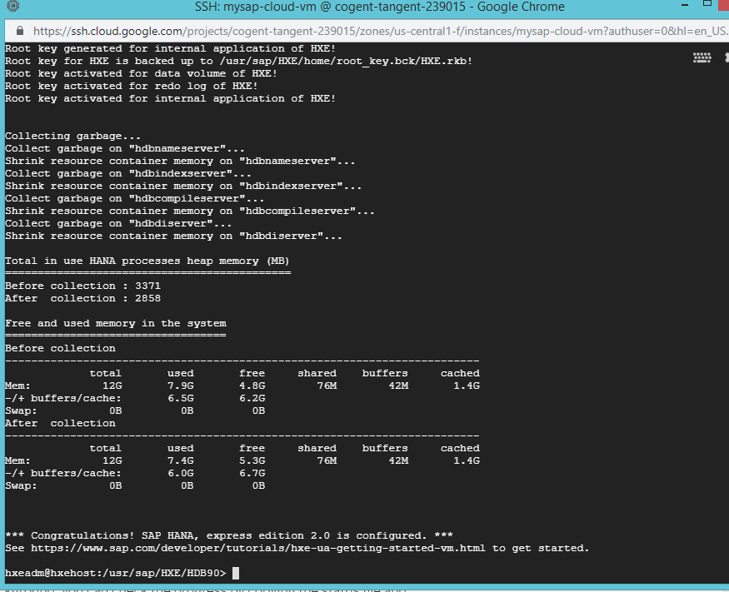

Once HANA Expression edition is installed. We need to note the external IP Address in order to access the Appliance.

